VisiFood

By
Asaf Weitzman
Nir Abadi
Guy Kayam
Yaniv Meshullam
Maayan Ohana Bashary

Supervisor
Dr. Moshe Butman

Git
AsafWeitzman/VisiFood (github.com)

Table of Contents

1. Project description 3
2. Related Work 3
2.1. Orcam Compay 3
2.2. AclarTech (Clarifruit) Company 3
3. Functional Description / Requirements 4
3.1. Development Requirements 4
3.2. User Requirements 4
4. Architecture 4-7
4.1. Client side (Front-end) 5
4.1.1. Usage Illustration 5
4.1.2. Mockup 6
4.2. Server side (Back-end) 7
4.3. Neural Network 7
5. Work plan 7

Project Description

Today people with visual impairments do not have the ability to get all the information they need about the products they want to purchase. We are interested in creating an accessible environment where the above consumers can get more information about the products they purchase.
Our platform aims to identify a fruit/vegetable and its color, as well as its expiration date and nutritional stickers located on the product.
The information about the product will be accessible to the customer via voice alert after image processing. The image processing will be performed on a smartphone device application.

The data on the identification of fruits/vegetables will be collected from existing databases that we found on the Internet (ImageNet, Kaggle).
Furthermore, we will gather images of expiration dates and nutritional stickers to build our very own database.

Related Work

Orcam Company
Orcam Technologies Ltd. is an Israeli company that develops and manufactures a computer vision-based device that assists the visually impaired, the blind and those with other disabilities.
The company focuses on reading, product identification (banknotes, credit cards) and face recognition. The company also identifies products in the supermarket by their barcodes.

The founders – Professor Amnon Shashua, Ziv Aviram.
Date of establishment – 2010.

AclarTech (Clarifruit) Company
Clarifruit platform facilitates fast, objective, and consistent fresh fruit and vegetable quality control. By providing fresh produce growers, wholesalers, marketing companies, and retailers with high-quality control data, it empowers them to make informed business decisions, reduce waste, and maximize profitability across the supply chain.

The founders – Avi Schwartzer and Ruby Boyarsky.
Date of establishment – 2017.

Functional Description / Requirements
The project needs to work on 3 different types of images, fruits/vegetables, expiration dates and nutritional stickers, which means we will need to develop 3 different algorithms, all of them will need to run on the same application.
The user will decide which option of the 3 he wants to use.
He will take a picture of the product, and the app will process the image using the chosen algorithm.
Finally, the app will inform the user of the gathered information via text-to-speech notification.

Development Requirements
We will require a database that includes tens of thousands of pictures of fruits and vegetables in different colors.
This database can be found on Kaggle at https://www.kaggle.com/chrisfilo/fruit-recognition and at https://www.kaggle.com/moltean/fruits, and on ImageNet at http://image-net.org/explore?wnid=n07707451.
Also, we will need to gather our own data about expiration dates and nutritional stickers.
We will do so by taking pictures of the information specified above, from different quality camera phones, over a long period of time.

User Requirements
The user is required to own a smartphone with a working camera.

Architecture

Training environment
Neural Network

Data
(Kaggle, ImageNet, our database)

Application
Client

Images
Notifications
Server

Neural
Network

Client side (Front-end)
An easy-to-operate application that will be accessible and take into consideration the disabilities of the user.

Usage Illustration
Upon entering the store or just before choosing a product, the user will turn the app on. The app will display 3 big buttons on its main screen. Upon pressing any button, the camera will start scanning the product. The user will then rotate the product until he hears an alert notifying him that the scan is finished. Finally, the app will notify the user about the information the app gathered.

After the process is finished, the user will be presented a button that will bring him back to the main screen of the app, from which he can start a new scan of a new product.

Mockup

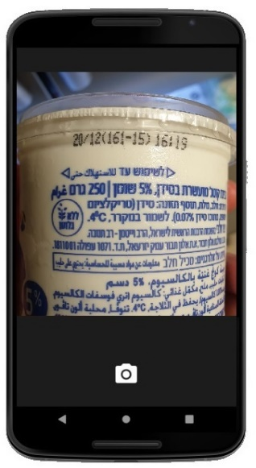
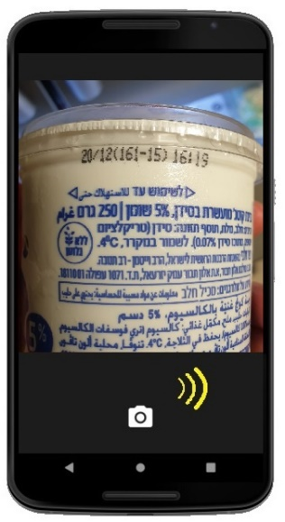
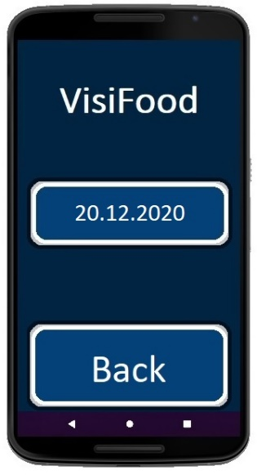
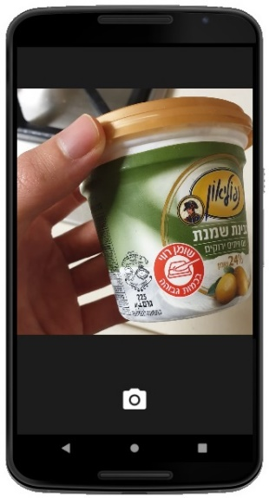
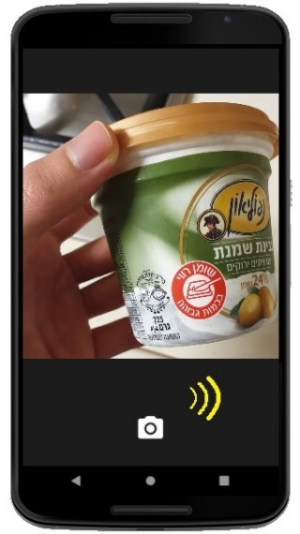
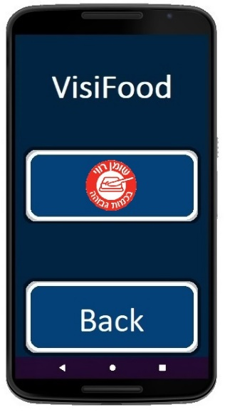
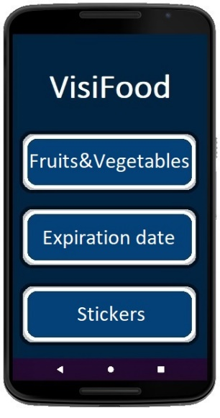
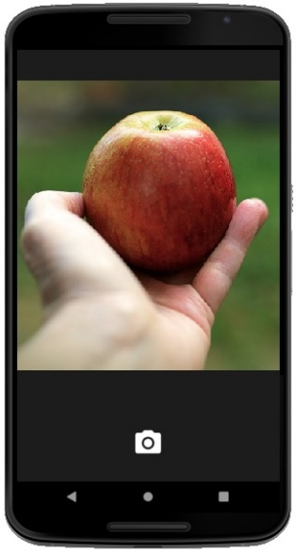
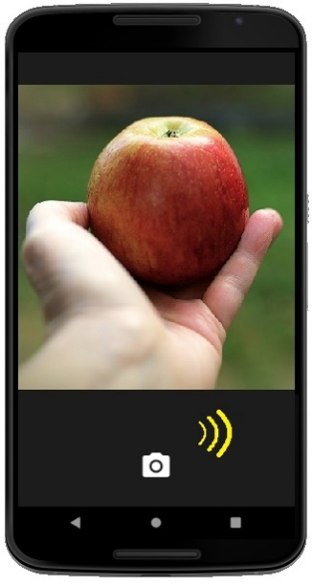
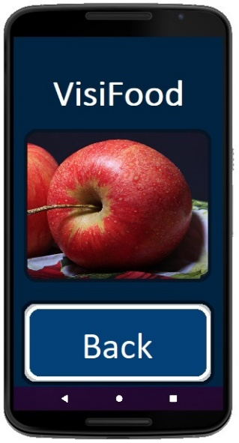

Server Side (Back-end)
The server will be located inside the app. It will include the neural network used to identify a product (the training of the network occurs in advance in a different environment e.g., home PC). The server will receive a collection of pictures that display the product from multiple angles as an input. It will then let the neural network process all the images to conclude the desired output needed to be sent to the client-side.

Neural Network
We will use PyCharm to build a neural network using TensorFlow, libraries with the same functionality and we will use a GPU from our college.

Work plan

Our work plan will be executed by the following milestones:
Milestone 1
Develop 3 algorithms, each of which will focus on a different aspect of the project.

Milestone 2
2.1. Train the neural networks with the algorithms mentioned above.
2.2. Test the networks’ functionality and correct any mistakes found.

Milestone 3
Develop the application focusing on accessibility for the visually impaired.
3.1. Client-side – Basic GUI able to be used by the user.
3.2. Server-side – Implementing the neural networks in the application.
At first, all team members will work together on the same tasks, gradually splitting to focus on different areas in the project.

